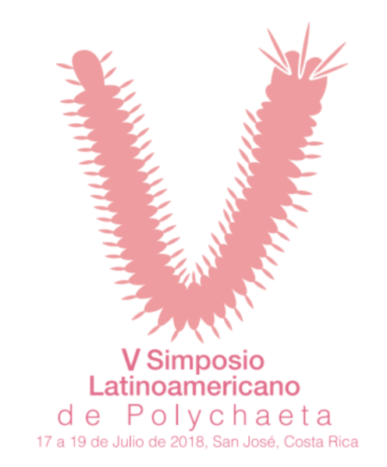
V Latin American Symposium of Polychaeta
Includes:
Day | Activity
Tuesday July 17 | Registration, Symposium Opening, AM Coffee Break / Lunch / Coffee Break PM
Wednesday July 18 | Full day Symposium, Refreshment AM / Lunch / Snack PM
Thursday July 19 | Full day Symposium, Refreshment AM / Lunch / Snack PM

Payment Form
Category | Prepaid  15 June, 2018 | From June 16 to July 16, 2018 | From July 17 to July 19, 2018
Professionals, PhD students | USD $ 230.00 | USD $ 255.00 | USD $ 280.00
Students (Bachelor's degree, Licentiate degree and Masters) | USD $ 200.00 | USD $ 225.00 | USD $ 250.00
Companions or Spouses | USD $ 200.00

Day | Additional Service: Closing Dinner
Thursday July 19 | Dinner USD $ 55.00

You can pay your participation to the Symposium organizer to an account in the United States for international participants or to an account in Costa Rica for local participants only. You can also pay with a VISA or MASTER CARD credit card. Please use the forms according to the chosen form of payment

Participant Information

Last name First Name
University or company Email
__Symposium __ Closing Dinner ___ Yes ___ No
Por favor indicar su categoría de Inscripción:
__ Student (Please attach your active student identification and certification)
__ Professional __ Companions or Spouses
¿Are you an Speakers ?: ___ Yes ___ No

Details for invoice and receipt
Name:
Concept:
Details:

Payment policies:
For your registration, full payment is required, amount as indicate on dates above mentioned.
In case the payment is 1 Month before the congress, a charge of USD $ 25.00 will apply.
In case of payment during the congress, a charge of USD $ 50.00 will apply.

Credit Card Payment Policies:
Meeting by Horizontes, gives you the option for a secure online payment link, which you can request through us to be send it, which you complete directly, with the facility that you can choose to make the payment thought Costa Rica National Bank of or through Paypal.

Policies for cancellation in case you are not able to attend:
Cancellations must be received in writing and the following penalties will apply:

- If you cancel your participation before March 14, 2018; there a penalty of USD $ 25.00
- If you cancel your participation between March 15 and June 15, 2018; a penalty of USD $ 50.00
- If you cancel your participation from June 16, 2018 a 100% penalty will apply.

CREDIT CARD AUTHORIZATION FORM

Request for secure online payment link submission
Please complete this form and send it to the e-mail or fax listed below.
Please indicted your full name in detail.

I, ______________________________________ make payment to Horizontes Travel Agency through secure online payment to my VISA or MasterCard
In the amount of USD $ ____________________________. This payment covers my participation in the
V Latin American Symposium of Polychaeta 2018.

FORM FOR WIRE TRANSFER INTERNATIONAL PARTICIPANTS
Please complete this form and send it to the e-mail or fax listed below.
Please indicate your full name in detail.

Account Name: Agencia de Viajes Horizontes de Costa Rica S.A.
Account Number: 102030703
Bank Name: Banco Internacional de Costa Rica
ABA or Routing Number: 066011567
SWIFT: COSRUS3M
Bank Contact Information:
4000 Ponce de León Suite 600
Coral Gables, Florida 33146
Phone: (305) 374-0855
Fax: (305) 381-6971

A deposit in the amount of: USD $ ____________ has been deposited into your account. This payment covers my participation in the V Latin American Symposium of Polychaeta 2018.

FORM FOR WIRE TRANSFER LOCAL PARTICIPANTS ONLY
Please complete this form and send it to the e-mail or fax listed below.
Please indicate your full name in detail.

Beneficiary: Travel Agency Horizontes de Costa Rica, S.A.
Account number in US dollars: 100-02-000-601949-1
Bank: Banco Nacional de Costa Rica
Swift: BNCRCRSJ
Code: UID: 019462
Bank Address: Avenida 1 y 3, Calle 2 y 4, San José Costa Rica

A deposit in the amount of: USD $ ____________ has been deposited into your account. This payment covers my participation in the V Latin American Symposium of Polychaeta 2018.

For more information please contact:
Meetings by Horizontes
Telephone: (506) 4052-5850 Fax: (506) 2256-4513
Email: meetings@horizontes.com
Www.meetingsbyhorizontes.com

